November 16, 2015
The Honorable Sylvia Mathews Burwell, Secretary
Department of Health and Human Services
200 Independence Avenue SW
Washington, DC 20201

Andy Slavitt, Acting Administrator
Centers for Medicare and Medicaid Services
Department of Health and Human Services
201 Independence Avenue, SW Room 445-G
Washington, D.C. 20201
Re: Texas Healthcare Transformation and Quality Improvement Program Section 1115 Medicaid Demonstration Project - Five Year Extension Proposal
Dear Secretary Burwell and Acting Administrator Slavitt:
The Center for Public Policies (CPPP) appreciates the opportunity to comment on Texas’ request for extension of the Texas Healthcare Transformation and Quality Improvement Program 1115 demonstration waiver.
CPPP is an independent public policy organization established in 1985. We use data and analysis, public education, advocacy, and technical assistance to advocate for solutions that enable Texans of all backgrounds to reach their full potential. Improving access to health care for Texans has been at the core of our mission and activities since our founding.
Background
Texas’ expiring 5-year Medicaid 1115 waiver provides critical support to Texas’ health care providers, through both “Uncompensated Care” (UC) funding for unpaid hospital bills of the uninsured and the gap between Texas Medicaid and federal Medicare rates, and through the “Delivery System Reform Incentive Payment” (DSRIP) half of the waiver which pays for innovative health projects in local communities. However, the waiver does not provide health insurance coverage to any Texans.
The waiver today provides about $4 billion a year in important federal health care funding, largely to Texas hospitals but also to other care providers in the state. Federal fiscal year 2016 is the final year of our original 5-year waiver approval period, and our comments today refer to the application by Texas Medicaid officials for a five-year extension. In 2016, the $4 billion in federal matching funds is budgeted to be split about evenly between the Uncompensated Care half of the waiver and Delivery System Reform Incentive Payment projects.
CPPP understands that Texas’ waiver was designed to be temporary, serving to build the capability to care for more Texans after Medicaid expansion and affordable private insurance coverage started in 2014. Texas applied and the federal government approved the waiver before the Supreme Court ruling of 2012 made it possible for Texas to not cover parents and other adults in Medicaid. Both Texas and federal Medicaid officials assumed at the time of approval that the waiver would help Texas prepare for having millions of uninsured gain coverage, both through Medicaid and through the private Marketplace.
In 2015, federal Medicaid officials announced new principles that the Centers for Medicare and Medicaid Services (CMS) intends to apply to future (or renewed) Medicaid Uncompensated Care pools in all states. May 2015 CMS correspondence states “uncompensated care pool funding should not pay for costs that would be covered in a Medicaid expansion” (either through traditional Medicaid Expansion or an 1115 coverage waiver). Two other principles articulated in that correspondence also have implications for Texas waiver extension request: “that Medicaid payments should support services provided to Medicaid beneficiaries and low-income uninsured individuals; and that provider payment rates must be sufficient to promote provider participation and access, and should support plans in managing and coordinating care.”
In addition to noting the important community and consumer benefits Texas’ 1115 waiver has provided, our comments also point out issues related to these principles as the Secretary and CMS consider the extension request.
General Waiver Extension Comments
CPPP strongly supports waiver extension or renewal, but we sto p short of recommending simply approving the full Texas Health and Human Services Commission (HHSC) request.
We strongly support the continued operations and funding of the Delivery System Reform Incentive Payment (DSRIP) projects, which have brought important and beneficial new capacity and tested new care delivery models. In particular, DSRIP projects have enhanced behavioral health services delivery capacity in Texas communities. Clearly, this new capacity and access to mental health and substance abuse care would be further enhanced (i.e., to an equal or even greater degree) if our state would couple the enhanced behavioral health service delivery capacity created with DSRIP funds, with comprehensive health coverage for adults.
CPPP also supports CMS’ goal to incorporate successful DSRIP findings and practices into statewide Texas Medicaid Managed Care contracts and payment structures to the greatest degree possible. These innovations should be made available to all Medicaid enrollees, and not limited to pockets of local innovation. While supporting ongoing DSRIP operations and funding at DY 2016 levels, we understand that streamlining of the unwieldy complex of over 1,400 DSRIP projects may be necessary to make meaningful transparency, evaluation, and accountability possible.
Texas is requesting an increase in the UC pool from $3.1 billion All Funds (about $2 billion federal, $1.1 billion from local Texas government funds) in year 5 of the current waiver, to $5.8 billion in the first year of the extension, $6.6 billion in the second, and $7.4 billion for the next three years, for a total of $34.6 billion over five years. CPPP understands that CMS plans to employ a study of Texas costs and spending, similar to the study used in Florida’s Low-income Pool renewal deliberations, to help determine the appropriate amount of a Texas UC pool continuation. We do not pretend today to know what the “right” final amount is for Texas’ UC pool in a waiver extension or renewal, but we agree with CMS that comprehensive coverage is a far more effective way to improve the health of Texans than waiting till Texans go to the Emergency Room or are hospitalized, and paying hospitals for that care after the fact.
Method of Finance and Distribution Issues
Many of the most challenging issues related to Texas’ waiver renewal request are related to a subject that has received considerable attention from federal Medicaid officials and Congress for a quarter century: the reluctance of state governments to adequately fund Medicaid program operations, and the consequent incentives for other stakeholders to seek alternative mechanisms to increase the non-federal funding available to state Medicaid programs, through provider taxes, donations, and intergovernmental transfers (IGT). Texas’ waiver sought to convert a growing Upper Payment Limit (UPL) program into an Uncompensated Care pool with greater transparency and accountability than its UPL predecessor, and a DSRIP pool with multiple quality-related goals and the intention to build infrastructure to serve the newly insured.
In many respects, Texas’ 1115 waiver has improved transparency of the portion of Texas Medicaid for which the non-federal share does not come from state General Revenues, most particularly Uncompensated Care funding. However, the status quo in Texas Medicaid continues to feature a large “siloed” component of supplemental payments supported almost entirely by local IGT, rather than the state budget. Texas HHSC reports that in 2013, a larger share of Texas Medicaid funding went to hospital supplemental payments (19% for DSRIP and UC payments, plus another 5% for Disproportionate Share Hospital payments) than to direct payments for inpatient and outpatient hospital care (21%). CPPP understands that Texas is not the only state in which supplemental payments equal or exceed direct hospital reimbursements.
This heavy reliance on off-state-budget sources of the non-federal funding share to compensate for the uninsured (rather than on actual payments for services delivered via comprehensive health care coverage) and for inadequate payment rates is contrary to CMS principles, to transparency, and to optimal health for Texas’ uninsured. It cannot be changed overnight, but CMS and Texas should continue along the path laid out under the CMS principles.
At the same time, CPPP recognizes that Texas hospitals serving the Medicaid population rely heavily on 1115 waiver funds, to continue to serve program enrollees and the uninsured population (which today still exceeds the Texas Medicaid population in size). Texas hospitals need more adequate Medicaid payment rates statewide, and the additional patient revenues that a Medicaid expansion or 1115-based adult coverage program would provide. These are improvements that the state’s legislative branch and executives—not federal Medicaid officials—must authorize. We support CMS’ goal to redirect Texas’ system towards providing real medical homes, versus paying bills of the uninsured after they land in the Emergency Department, and paying adequate rates to all Medicaid hospitals rather than supplemental payments. But, we also acknowledge that movement toward these goals must be undertaken in a manner and on a timeline that will not create a crisis in Texas’ safety net.
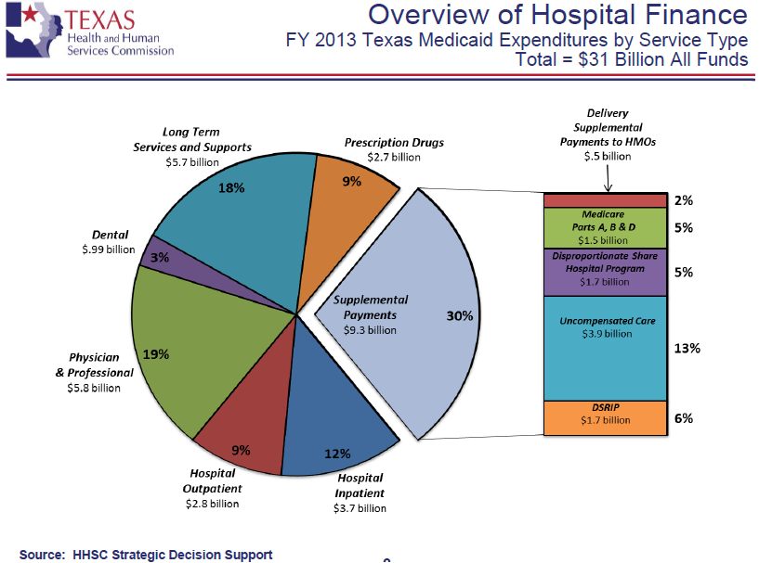
CPPP is also concerned that the funding structure for Texas’ waiver may be—unintentionally but significantly—undermining “state-wideness” in the program. As noted, 1115 waiver funding to hospitals nearly equals the amount of direct reimbursements for care by Medicaid. But, only the hospitals and participating providers with access to a source of local/regional funding for an Inter-governmental Transfer (“IGT”) can access the UC or DSRIP benefits of Texas’ waiver. This raises the very serious concern that the waiver supports a de facto system in which wealthier jurisdictions with greater fiscal capacity essentially are able to offer a richer and more generous Medicaid program, paying better rates and housing more innovative programs, than poorer Texas jurisdictions with less fiscal capacity.
Smaller community hospitals (and communities without hospitals) with limited local-government fiscal capacity to provide IGT cannot benefit significantly from either DSRIP or UC. Because of this, smaller hospitals are feeling the full brunt of cost containment policies under the ACA that were intended to be balanced with patient revenues from those newly insured by Medicaid. Larger hospitals with access to local IGT are protected from the full impact of the cost containment policies by their waiver revenues. We believe that in Texas, as in Florida, “fundamental changes to the distribution approach are needed so that payments support services provided to beneficiaries and low-income individuals.”
It is also worth noting that the largest providers of IGT, public hospital financing districts in Texas high-population urban counties, essentially only benefit from the federal share of waiver payments, as they are providing the non-federal share.
Method of finance issues are not limited to the UC component of Texas waiver. They also affect the ability of Texas Medicaid to integrate DSRIP projects into Medicaid Managed Care policy and rates, and this extends beyond the stark lack of coverage for a majority of Texas adults with incomes below 138 percent of the federal poverty income. A number of promising DSRIP projects offer service modalities and settings, or services delivered by provider types that are not currently offered in the Texas Medicaid State Plan. To integrate these into Medicaid Managed Care models, Texas Medicaid officials will have to request and receive increased state budget appropriations; that is, will have to convert these activities from off-budget to on-state-budget financing, funded via Medicaid Managed Care premiums.
Conclusion
In summation, CPPP supports the extension of Texas’ 1115 waiver, but calls on the Secretary and CMS to carefully review Texas’ proposal and take steps to move Texas Medicaid away from inequitable and opaque financing, and toward comprehensive coverage, adequate rates, innovative delivery practices, and a truly statewide program. We understand that balancing these needs will be a challenging task for Texas Medicaid and federal Medicaid officials.
We acknowledge that the Texas legislature and Governor hold equal or greater responsibility for supporting the Texas safety net, and our state government has at its disposal the means to avoid any negative impact to Texas hospitals, by implementing Medicaid expansion or an 1115 coverage expansion waiver. Indeed, our leadership could achieve a dramatic increase in federal support for Texas, as every estimate to date (including the states’ own models) predicts a net gain of $4 to $9 billion a year from covering adults to 138% FPL. And, as noted, the list of recent approved 1115 coverage expansion waivers clearly demonstrates the opportunity for states to test an unprecedented variety of delivery designs.
We will continue to urge our Texas state leadership to do the best thing for both Texans’ health care system and taxpayers’ well-being: to modify this proposal and link it to a coverage program for our uninsured adults with incomes up to 138 percent of the federal poverty income level.
Thank you again for the opportunity to comment on this important and complex matter. Questions related to these comments may be addressed to: Anne Dunkelberg, Associate Director, dunkelberg@cppp.org ; Center for Public Policy Priorities, 7020 Easy Wind Drive - Austin, Texas 78752. Phone (512) 320-0222 (ext.102) – www.cppp.org.

