Testimony on S.J.R. 2 / S.B. 9
Eva DeLuna Castro, deluna.castro@cppp.org

CPPP Opposes the Proposed Historical “Population Plus Inflation” Formula to Determine the Article VIII, Section 22 Growth Limit

The Center for Public Policy Priorities is an independent public policy organization that uses data and analysis to advocate for solutions that enable Texans of all backgrounds to reach their full potential. Many of these solutions require Texas state and local governments to be able to raise and spend the revenue needed to fund necessary services such as preK-12 public education, state-supported universities and community colleges, health care, and public safety and consumer protection.
The current Article VIII limit requires that appropriations not grow faster than the state’s economy. The Legislative Budget Board information below shows that Personal Income growth rates adopted by the LBB to comply with Article VIII have generally turned out to be lower than either actual personal income or growth in the state economy as measured by Gross State Product. (GSP data are from the Comptroller’s office, Winter 2014-15 Forecast, Fiscal Years 1991-2041.) The few recent exceptions to this have occurred when a recession was unforeseen by economic forecasters. In those instances, population and inflation would have required greater growth than indicated by GSP growth.
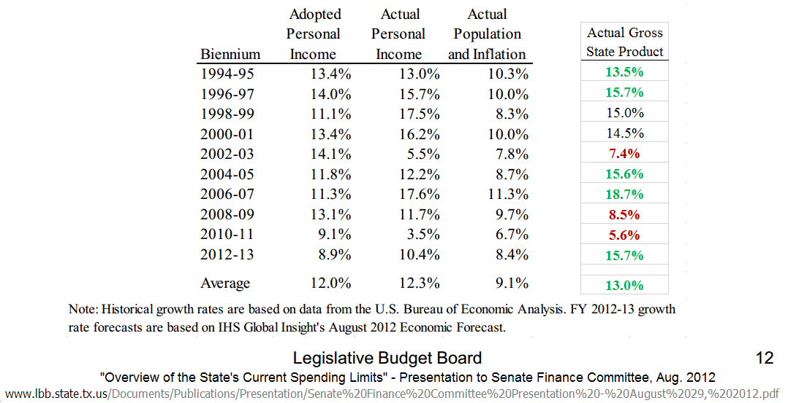

Using the LBB estimates of population and inflation, and applying the previous biennium’s allowable growth rate to All Funds revenue, rather than only to taxes that are not constitutionally dedicated, it is possible to determine what impact S.J.R. 2 and S.B. 9 might have had if they had been in effect for the past two decades.
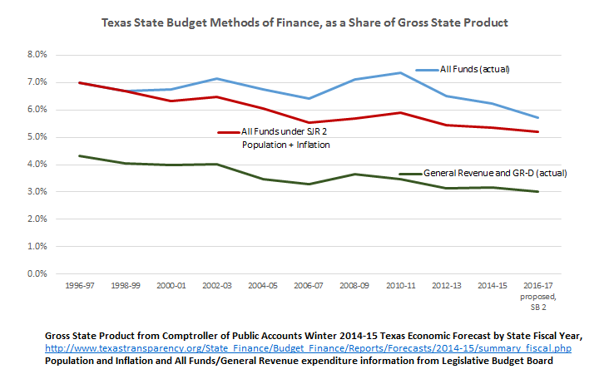

In the 2010-11 biennium – and only because of Recovery Act “stimulus” aid to states – All Funds spending peaked at 7.3 percent of the economy, the same share it accounted for in 1994-95. In all other budget biennia shown above, All Funds spending as a share of the economy stayed below the 1994-95 level. However, if a “population plus inflation” limit had been in place, all budgets starting with the 2000-01 biennium would have required the House and Senate to exceed the limit (with a three-fifths vote, rather than the current simple majority) or make significant cuts in the range of 6 to 20 percent. For the 2016-17 biennium, SB 2 as introduced would be $19 billion higher than the amount of spending allowed under a population plus inflation cap.
Texas has a long-standing history of being extremely fiscally conservative and can consistently be found in the bottom ten states in terms of taxes collected or dollars spent per resident. It is hard to imagine how the Legislature could have made even more cuts to state spending than were enacted in the 2003 and 2011 sessions. It is equally difficult to imagine how these additional cuts would have improved the highways and other infrastructure that economic growth requires. Additional budget cuts would certainly not have expanded access to health care or to educational opportunities for the millions of hard-working Texans who receive those services through the state budget. For these reasons, we urge the 84th Legislature to leave unchanged the current constitutional limits, which are working as intended to keep Texas a low-spending state.

